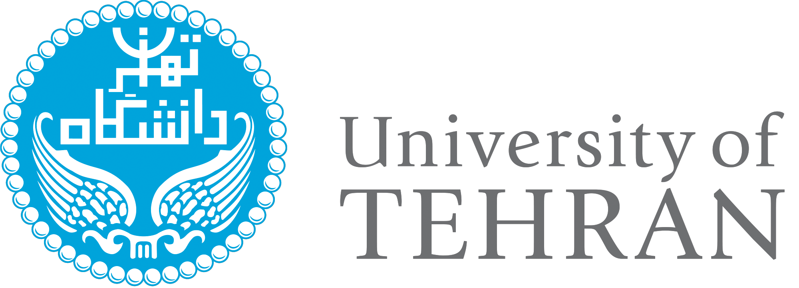

Memorandum of Understanding

Between

…………………………….

And

University of Tehran, Iran

……………………. and University of Tehran wishing to intensify the existing cooperative relations between the two institutions, especially to develop academic and cultural interchanges through mutual assistance in the areas of education and research, technology and commercialization of science and technology transfer and customization and localization agree as follows:

1. Participating parties

The participating parties will be ………………….. and University of Tehran.

2. Area
The area of cooperation includes, subject to mutual consent, any program offered by either of the participating parties as felt desirable and feasible on either side to foster and develop the cooperative relationship between the two institutions.

3. Methods
Assistance shall be carried out, subject to availability of funds and the approval of each institution, through such activities or programs as:

1. Joint research activities (including exchange of faculty members and research students)
2. Participation in seminars and academic meetings
3. Exchange of academic materials and other information
4. Special short-term academic programs
5. Exchange of Students
6. Joint supervision of M.Sc. and Ph.D. theses
7. Joint supervision of Post. Doc researchers
8. Development of joint research institutes, center of excellence and technology parks
9. Establishment of joint and dual B.S., M.Sc. and Ph.D. programs
10. Cooperation in the scientific committees of M.Sc. and Ph.D. theses and joint research projects
11. Cooperation in establishment of multi disciplinary programs in M.Sc. and Ph.D. courses
12. Other activities as deemed mutually appropriate
13. Each institution shall facilitate the joint publication of books, and the inclusion of specialist works from the other institution in its own journals, providing they meet the regulations of the journal in question.
14. Both institutions shall provide the link to the website of the other on its homepage.

The terms of such mutual assistance and necessary budget for each program and activities shall be mutually discussed and agreed upon in writing by both parties prior to the initiation of the particular program or activity, and such program and activity shall be negotiated on a mutual bases.

- Intellectual Property
The disposition of intellectual property created by the participating parties in performance of this Memorandum of Understanding will be guided by that University’s applicable policies and the following principles:

Disclosure
The participating parties will disclose Intellectual Property from one to another to facilitate performance of the research and training activities of this Memorandum of Understanding and to determine appropriate measures to be taken regarding the Intellectual Property.

Ownership
Intellectual Property created in performance of this Memorandum of Understanding (“Intellectual Property”) shall be owned in accordance with the policies and procedures of the party or the parties whose personnel created such Intellectual Property.

Right to Use
Each participating party will have a non-exclusive, royalty- free license to use the other participating party’s Intellectual Property (a) in performance of the Memorandum of Understanding activities, and (b) for research and teaching use. Any other use will be subject to the negotiation of a license agreement with the owners of the subject Intellectual Property.

- Principles
Both parties assert that participants under this Memorandum of Understanding will be selected on the bases of the merit without regard to race, national or ethnic origin, color, religion, age, sex, marital status or physical handicap University of ………………… and University of Tehran will each accept the participants selected by the other party if mutually acceptable academic and /or professional qualifications and standards are met. All participants will be treated in the same non-discriminatory manner in carrying out the provisions of this Memorandum of Understanding, subject to the provision of the policies and requirements of each of the institutions. Any violation of these Principles will be considered as grounds for terminating this Memorandum of Understanding.

- Effective Date and Length of Memorandum of Understanding
This Memorandum of Understanding will remain in force for a period of five years subject to the availability of funds, and any amendment and/or modification of the Memorandum of Understanding will require written approval of the chief administrative office of each contracting institution and shall be appended hereto.

After the initial five-year period, this Memorandum of Understanding may be renewed automatically subject to the approval of the both parties.

Either party reserves the right to terminate this Memorandum of Understanding upon six months written notice to the other. Any damage due to one sided termination of the cooperation on the other side should be taken into account by responsible side on mutual cooperation.

This Memorandum of Understanding shall take effect when signed by each side.

For the ……………………... | For University of Tehran
……………………... | Prof. Seyed Mohammad Moghimi
President | President
Date: | Date:

